The SEEALL Academy Mr. Angelo J. Sacco, Principal

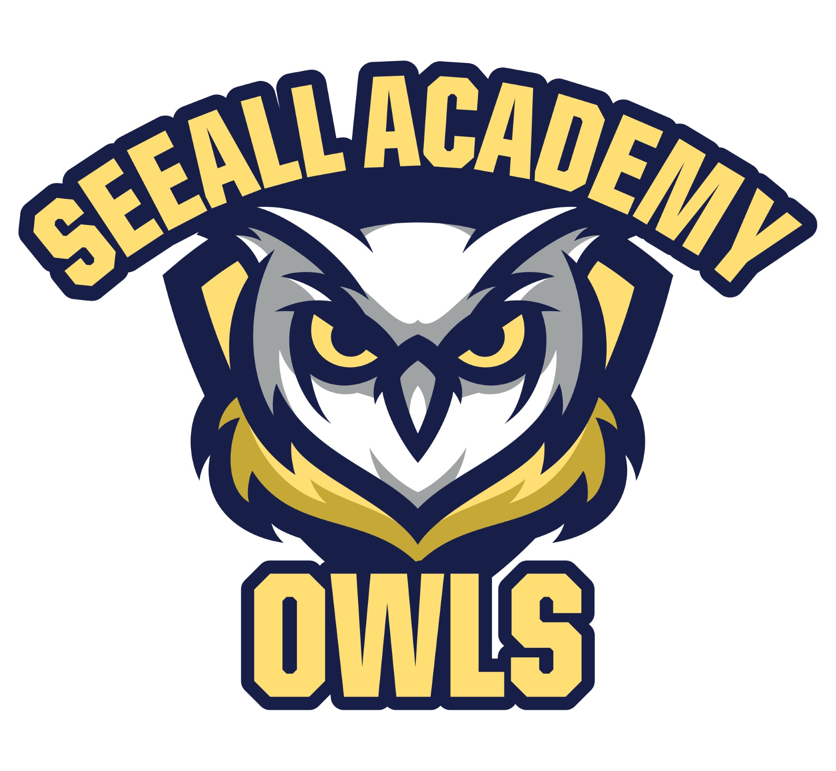
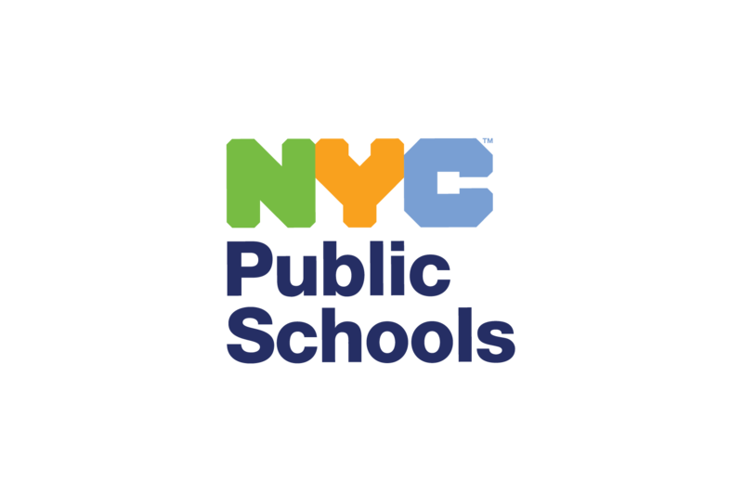
5601 16th Avenue, Brooklyn, NY 11204 Ms. Angela M. Panetta, Assistant Principal
Telephone # (718) 851-8070 Fax # (718) 853-9308 Ms. Nicole Adisano, Assistant Principal
Mr. Andrew Wells, Assistant Principal

March 19, 2025
Dear Parent or Guardian:
Your child’s health is important to us. At an early age, children develop habits that will shape their health throughout their lives. The New York State Department of Education requires Health Education for all students in grades K-12, including lessons on HIV. In New York City Public Schools, Health Education classes include lessons on personal health and safety; nutrition and physical activity; social, emotional, and mental health; alcohol, tobacco, and other drug-use prevention; growth and development; and disease and illness prevention.
This year, your child will have lessons from a curriculum called Growing Up and Staying Safe. The lessons are medically accurate, inclusive, and age appropriate. New York City Public Schools developed them in partnership with health experts, community leaders, parents, and educators.
In kindergarten through grade 6, students learn how to:
· stay healthy and avoid illnesses,
· develop self-worth and respect for their bodies,
· advocate for kindness and empathy, and
· communicate with trusted adults.
Please review the included grade level overview(s) to learn more about the lessons. The lessons can be found oun our school website.
Parents, guardians, and schools share a common goal: we want students of all ages to be healthy in all aspects of their lives. We respect your role as parents/guardians in teaching your child about healthy behaviors that support your family’s beliefs and values. We encourage you to discuss with your child what they are learning in health class, and to speak to your child's teacher, parent coordinator, or me. If you have any questions, please contact Ms. Ferguson at x1102.
Sincerely,
Angelo J. Sacco
Principal

