The SEEALL Academy Mr. Angelo J. Sacco, Principal

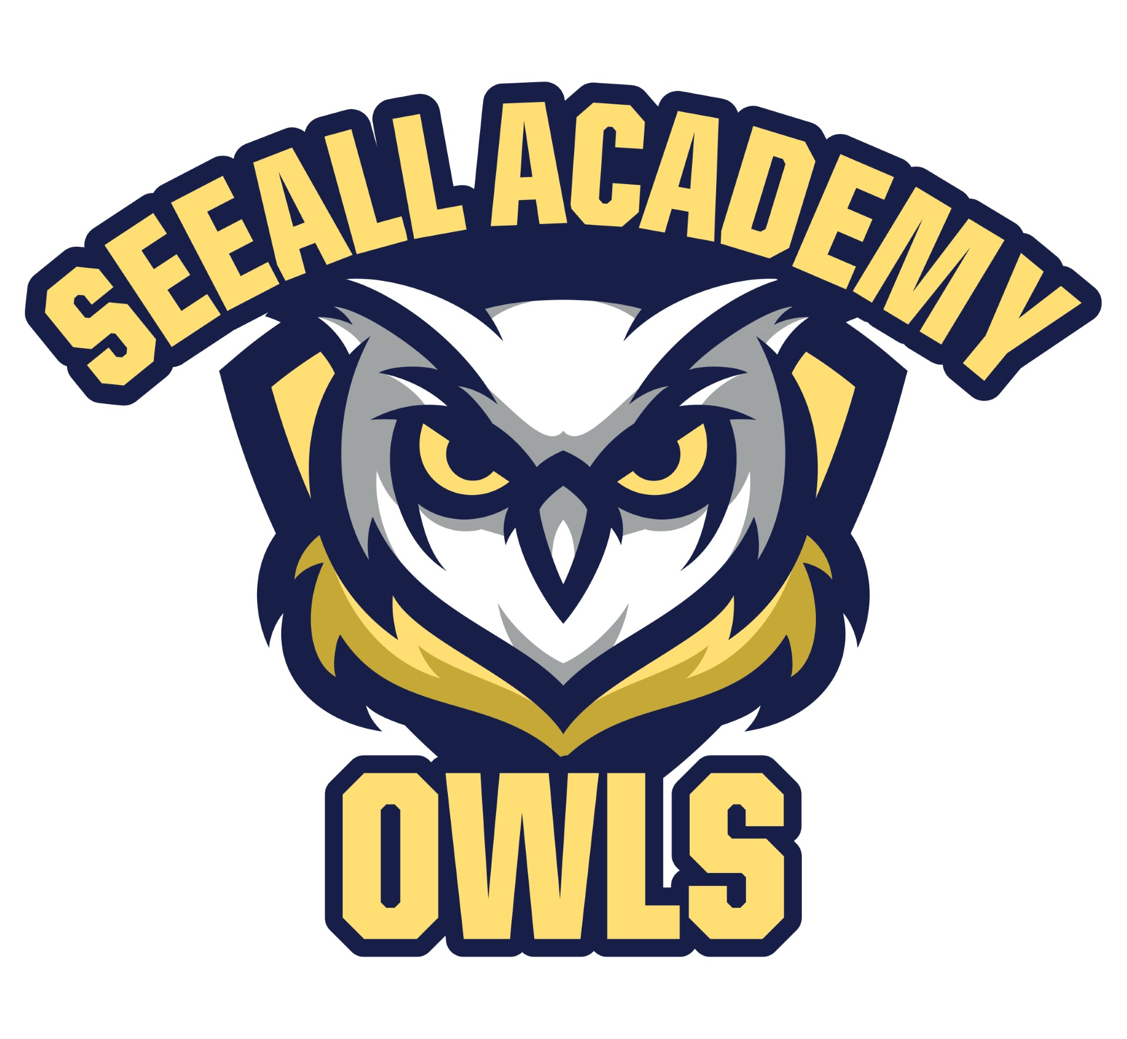
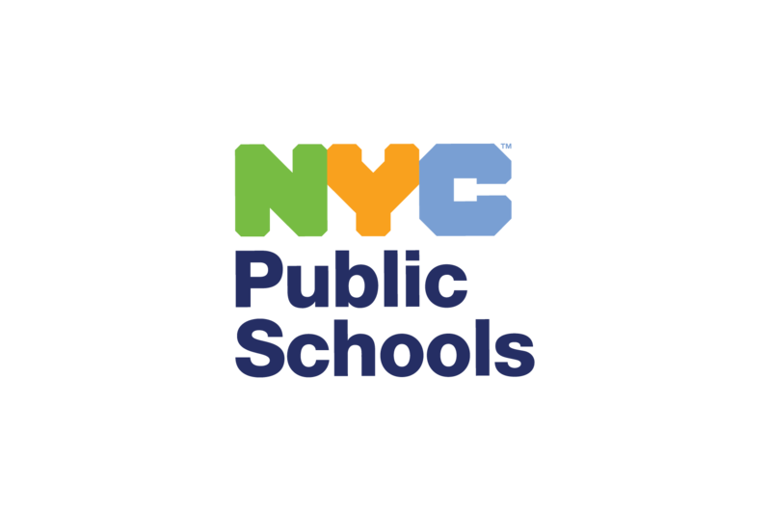
5601 16th Avenue, Brooklyn, NY 11204 Ms. Angela M. Panetta, Assistant Principal
Telephone # (718) 851-8070 Fax # (718) 853-9308 Ms. Nicole Adisano, Assistant Principal
Mr. Andrew Wells, Assistant Principal

March 19, 2025
Dear Parent or Guardian:
HIV and AIDS are among the most serious health problems Americans have ever faced. Advances in medicine now allow people with HIV to live long and healthy lives, but there is still no cure. Health Education plays a critical role in helping students learn to make healthy choices and to protect themselves and others.
The New York State Education Department requires HIV education for students. This year, your child will have lessons from a curriculum called Growing Up and Staying Safe. The lessons are medically accurate, inclusive, and age appropriate. New York City Public Schools developed them with health experts, community leaders, parents, educators, and students.
In middle school, students learn:
· how HIV affects the immune system,
· characteristics of healthy relationships, and
· the importance of communicating with parents or caregivers.
Please also review the included grade level overview(s) on our school website to learn more about the lessons.
You have the right to excuse your child from certain lessons that teach about methods of HIV prevention. If you would like your child to be excused, you must email 20K180@schools.nyc.gov by March 28, 2025, that:
· Your child should not be in the classroom during lessons about methods of HIV prevention; and
· You will teach your child about HIV prevention at home.
Parents, guardians, and schools share a common goal: we want students of all ages to be healthy in all aspects of their lives. We respect your role as parents/guardians in teaching your child about healthy behaviors that support your family’s beliefs and values. We encourage you to discuss with your child what they are learning in health class, and to speak to your child's teacher, parent coordinator, or me to learn more about the curriculum. If you have any questions, please contact me at [Phone Number].

Sincerely,
Angelo J. Sacco
Principal

